New thematic brochure:
Measurement technology for industrial gases

Klingenberg, April 2020.- In a new brochure, WIKA summarises the topic “Measurement technology for industrial gases” in a compact form.

The subject is structured according to typical applications, from medical gases, through LNG/CNG accessories to valves with integrated pressure regulators. For each application, a corresponding spectrum of mechanical and electronic measuring instruments is assigned from the extensive WIKA portfolio. The brochure is primarily aimed at OEM manufacturers, for whom individual solutions can also be developed, for example, for the integration of measuring instruments into special case designs. In order to be able to react adequately to market requirements, WIKA also exchanges ideas with industrial gas companies and end users.

The new brochure can be downloaded as a PDF file from the website www.wika.com or requested as a print version.

Number of characters: 848
Key words: Industrial gases brochure

Manufacturer:
WIKA Alexander Wiegand SE & Co. KG
Alexander-Wiegand-Straße 30
63911 Klingenberg/Germany
Tel. +49 9372 132-5049
Fax +49 9372 132-406
vertrieb@wika.com
www.wika.de

WIKA company photograph:
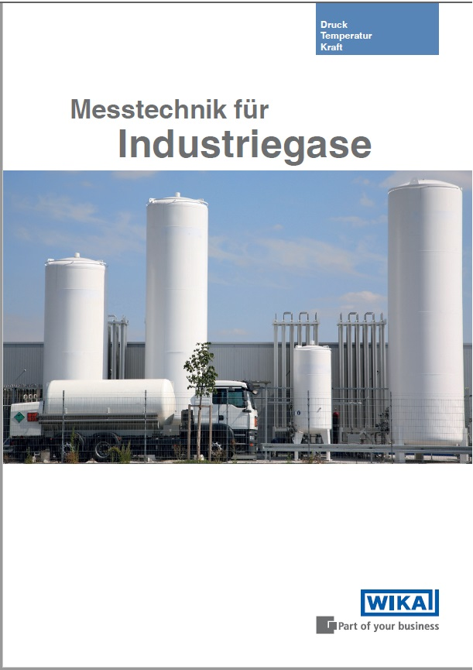

Edited by:
WIKA Alexander Wiegand SE & Co. KG
André Habel Nunes
Marketing Services
Alexander-Wiegand-Straße 30
63911 Klingenberg/Germany
Tel. +49 9372 132-8010
Fax +49 9372 132-8008010
andre.habel-nunes@wika.com
www.wika.de

WIKA press release

