MH-3: New pressure transmitter for mobile working machines

Klingenberg, October 2015.
WIKA's new OEM pressure transmitter for mobile working machines, model MH-3, features more powerful electronics. In addition, the follow-up model to the successful MH-2 offers the possibility of signal clamping and has a diagnostic function.

Using the signal clamping, pressure spikes, which can be generated by fast-acting valves, for example, are clipped and thus faults in the machine are prevented. With the diagnostic function, faults can be detected based on a defined output signal.

The new MH-3 offers the “look and feel” of its predecessor and also its exceptional robustness. With its highly resistant PBT case, the instrument withstands vibrations, pressure spikes (CDS system) and temperature shocks. The sensor of the hermetically welded, thin-film measuring cell has been designed for measuring ranges of
0 ... 40 bar to 0 ... 600 bar. It measures, with long-term stability and resistance against load cycling, to an accuracy of 1.0 % of span.

Number of characters: 955
Key word: MH-3

Manufacturer:
WIKA Alexander Wiegand SE & Co. KG
Alexander-Wiegand-Straße 30
63911 Klingenberg/Germany
Tel. +49 9372 132-0
Fax +49 9372 132-406
vertrieb@wika.com
www.wika.de

WIKA company photograph:
New WIKA pressure transmitter for mobile working machines, MH-3

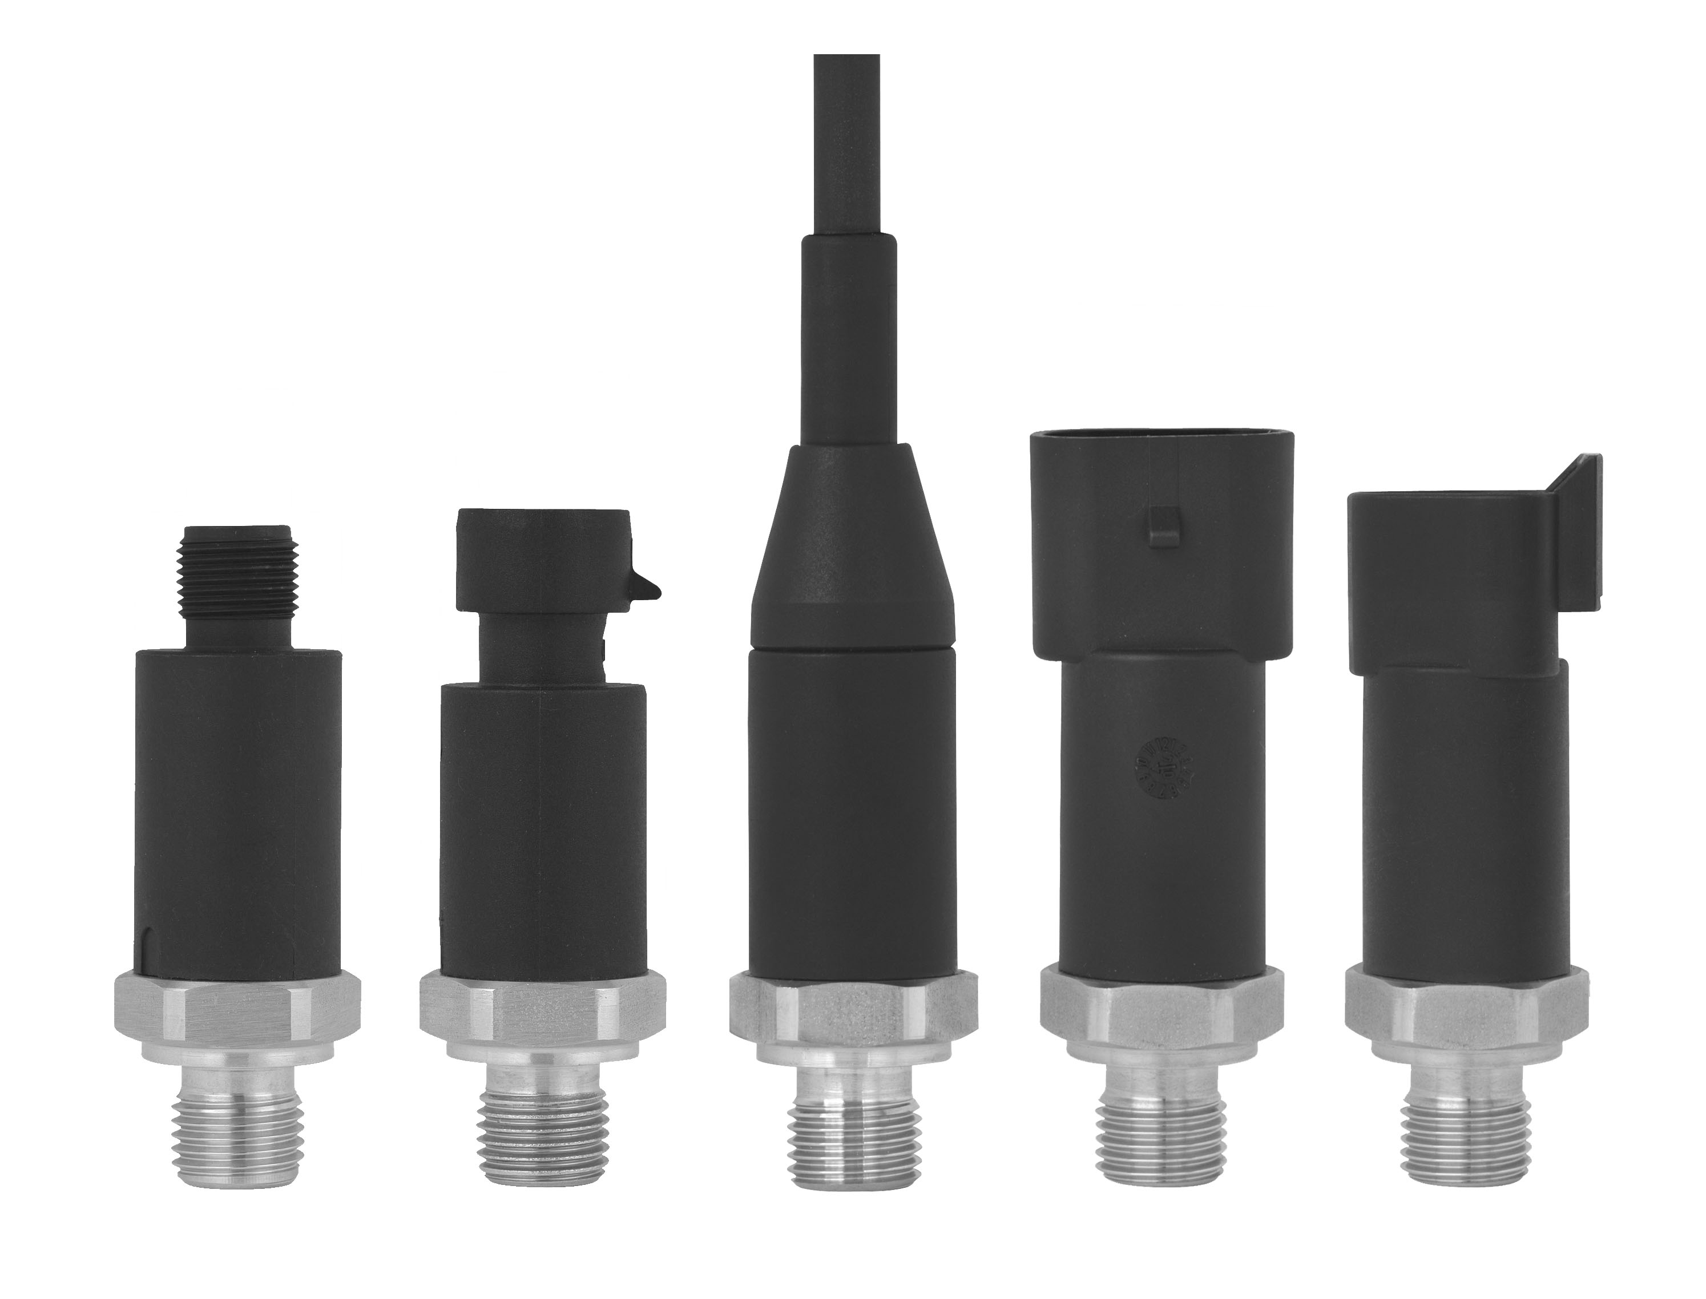

Edited by:
WIKA Alexander Wiegand SE & Co. KG
André Habel Nunes
Marketing Services
Alexander-Wiegand-Straße 30
63911 Klingenberg/Germany
Tel. +49 9372 132-8010
Fax +49 9372 132-8008010
andre.habel-nunes@wika.com
www.wika.de

WIKA press release 22/2015

